CS 499 Module One Assignment Template

Complete this template by replacing the bracketed text with the relevant information.

- Self-Introduction: Address all of the following questions to introduce yourself.

  - How long have you been in the Computer Science program?
I started my degree at Hillsborough Community College in 2021 and joined SNHU’s program in 2023.

  - What have you learned while in the program? List three of the most important concepts or skills you have learned.
The most important concepts I learned in this program include the following: Secure coding according to adopted security standards and associated QA testing. Database development and management. As well as Algorithms and data structures.

  - Discuss the specific skills you aim to demonstrate through your enhancements to reach each of the course outcomes.
In my enhancements I hope to demonstrate secure, stable, and efficient code that is scalable and in line with best practices, code written and commented comprehensibly to a high professional standard that allows for collaborative black box development. I wish to show how diverse my skillset is and my flexibility in tackling new algorithmic challenges that meet established goals. I also wish to show strong and secure database development and administrative skills as well as developing appealing and functional front-ends. Finally, though it is outside the scope of this class I’d like my portfolio to demonstrate my proficiency in COBOL and various game engines.

  - How do the specific skills you will demonstrate align with your career plans related to your degree?
Given the turbulence within the industry my career path is not set in stone so I will be applying for a diverse range of positions from Game Developer, to Full-Stack Developer, to Embedded systems programmer, to Database administration.

  - How does this contribute to the specialization you are targeting for your career?
Given the turbulence within the industry my career path is not set in stone so I will be applying for a diverse range of positions from Game Developer, to Full-Stack Developer, to Embedded systems programming, to Database administration. I wish to build a portfolio which shows a diverse skill set and can be trimmed down to show proficiency in specializations.

- ePortfolio Set Up:

  - Submit a screen capture of your ePortfolio GitHub Pages home page that clearly shows your URL.
    - You already have a repository in GitHub where you uploaded projects in previous courses. Your ePortfolio will reside in GitHub but can link to work at other sites, such as Bitbucket.

  - Use the GitHub Pages link in the Resource section for directions on:
    - How to create your GitHub website and publish code to GitHub Pages
    - Issues, such as adding links to other sites

  - Paste a screenshot of your GitHub Pages home page with your URL clearly showing in the space below.

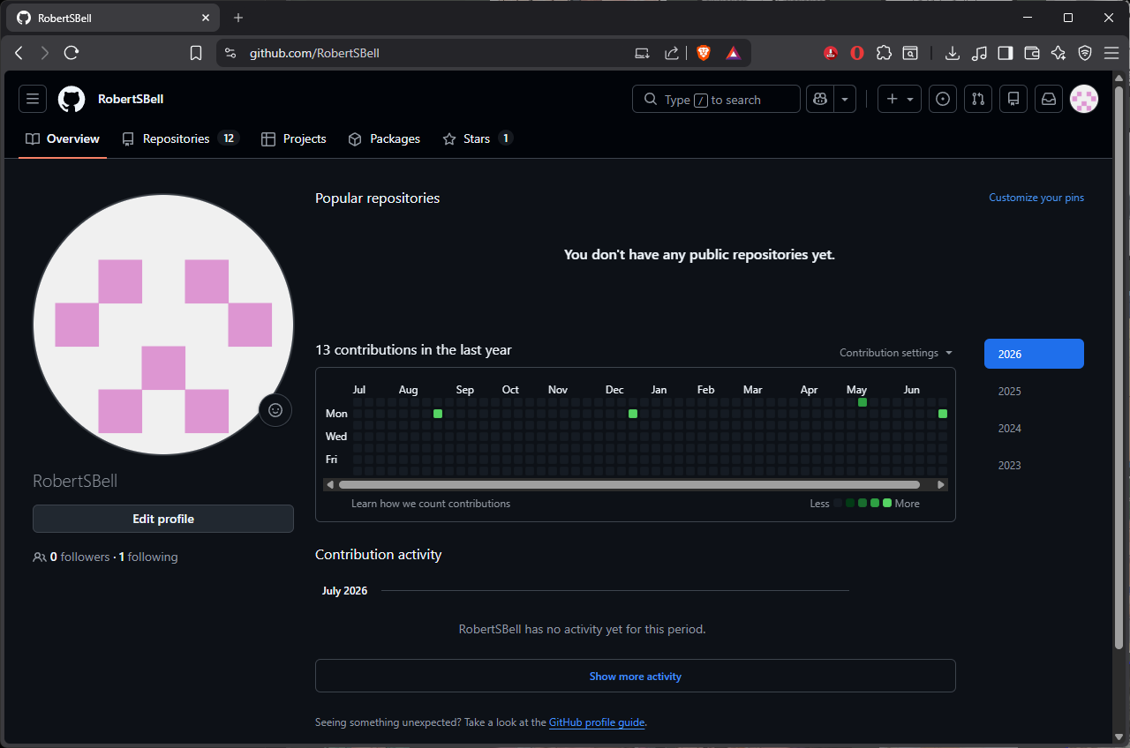
- Enhancement Plan:

  - Category One: Software Engineering and Design
    - Select an artifact that is aligned with the software engineering and design category and explain its origin. Submit a file containing the code for the artifact you choose with your enhancement plan.

My final project for Full-Stack Development.

Note: Your artifact may be work from the following courses:

- IT 145: Foundation in Application Development
- CS 250: Software Development Lifecycle
- CS 260: Data Structures and Algorithms
- IT 315: Object Oriented Analysis and Design
- CS 320: Software Testing, Automation, and Quality Assurance
- CS 330: Computational Graphics and Visualization
- CS 340: Advanced Programming Concepts
- CS 350: Emerging Systems Architectures and Technologies
- CS 360: Mobile Architecture and Programming
- IT 365: Operating Environments
- IT 380: Cybersecurity and Information Assurance
- CS 405: Secure Coding
- CS 410: Reverse Software engineering
- IT 340: Network and Telecommunication Management
- IT 380: Cybersecurity and Information Assurance

    - Describe a practical, well-illustrated plan for enhancement in alignment with the category, including a pseudocode or flowchart that illustrates the planned enhancement.

The code is already functional but needs to be cleaned up, more clearly commentated, and consistently updated to Angular’s modern syntax. Graphical assets should be updated and the definitions updated to be more useful. Implement secure coding practices within the design.

For this category of enhancement, consider improving a piece of software, transferring a project into a different language, reverse engineering a piece of software for a different operating system, or expanding a project’s complexity. These are just recommendations. Consider being creative and proposing an alternative enhancement to your instructor.

Think about what additions to include to complete the enhancement criteria in this category. Since one example option is to port to a new language, that is the kind of scale that is expected. This does not mean you need to port to a new language but instead have an equivalent scale of enhancement. Underlying expectations of any enhancement include fixing errors, debugging, and cleaning up comments, but these are not enhancements themselves.

    - Explain how the planned enhancement will demonstrate specific skills and align with course outcomes.

      - Identify and describe the specific skills you will demonstrate that align with the course outcome.
Deliver efficient, modular, scalable, secure, and efficient code in both front-end and back-end development.

      - Select one or more of the course outcomes below that your enhancement will align with.

It will align with all course outcomes but especially #2.

Course Outcomes:

- Employ strategies for building collaborative environments that enable diverse audiences to support organizational decision-making in the field of computer science.
- Design, develop, and deliver professional-quality oral, written, and visual communications that are coherent, technically sound, and appropriately adapted to specific audiences and contexts.
- Design and evaluate computing solutions that solve a given problem using algorithmic principles and computer science practices and standards appropriate to its solution while managing the trade-offs involved in design choices.
- Demonstrate an ability to use well-founded and innovative techniques, skills, and tools in computing practices for the purpose of implementing computer solutions that deliver value and accomplish industry-specific goals.
- Develop a security mindset that anticipates adversarial exploits in software architecture and designs to expose potential vulnerabilities, mitigate design flaws, and ensure privacy and enhanced security of data and resources.

  - Category Two: Algorithms and Data Structures

- Select an artifact that is aligned with the algorithms and data structures category and explain its origin. Submit a file containing the code for the artifact you choose with your enhancement plan. You may choose work from the courses listed under Category One.

My embedded systems python code for the final thermostat project in CS 350.

- Describe a practical, well-illustrated plan for enhancement in alignment with the category, including a pseudocode or flowchart that illustrates the planned enhancement.

My goal is to port the code to a cheaper microcontroller rather than the expensive SBC called for in the assignment. Adapting the code to run as a proper embedded system rather than as a application manually executed in a linux desktop OS.

For this category of enhancement, consider improving the efficiency of a project or expanding the complexity of the use of data structures and algorithms for your artifact. These are just recommendations. Consider being creative and proposing an alternative enhancement to your instructor. Note: You only need to choose one type of enhancement per category.

Think about what additions to include to complete the enhancement criteria in this category. Since one example option is to port to a new language, that is the kind of scale that is expected. Perhaps you might increase the efficiency and time complexity of an algorithm in an application and detail the logic of the increased time complexity. Remember, you do not need to port to a new language but instead have an equivalent scale of enhancement. Underlying expectations of any enhancement include fixing errors, debugging, and cleaning up comments, but these are not enhancements themselves.

- Explain how the planned enhancement will demonstrate specific skills and align with course outcomes.

  - Identify and describe the specific skills you will demonstrate to align with the course outcome.

Flexibility and adaptability including the ability to code for specialty hardware and use cases.

  - Select one or more of the course outcomes listed under Category One that your enhancement will align with.

Outcomes 2, 3, and 4.

  - Category Three: Databases

    - Select an artifact that is aligned with the databases category and explain its origin. Submit a file containing the code for the artifact you choose with your enhancement plan. You may choose work from the courses listed under Category One.

Project Two from CS-340

    - Describe a practical, well-illustrated plan for enhancement in alignment with the category, including a pseudocode or flowchart that illustrates the planned enhancement.

Clean up commentary to align with professional standards.

For this category of enhancement, consider adding more advanced concepts of MySQL, incorporating data mining, creating a MongoDB interface with HTML/JavaScript, or building a full stack with a different programming language for your artifact. These are just recommendations; consider being creative and proposing an alternative enhancement to your instructor. Note: You only need to choose one type of enhancement per category.

Think about what additions to include to complete the enhancement criteria in this category. Since one example option is to port to a new language, that is the kind of scale that is expected. Perhaps you might increase the efficiency and time complexity of an algorithm in an application and detail the logic of the increased time complexity. Remember, you do not need to port to a new language but instead have an equivalent scale of enhancement. Underlying expectations of any enhancement include fixing errors, debugging, and cleaning up comments, but these are not enhancements themselves.
    - Explain how the planned enhancement will demonstrate specific skills and align with course outcomes.

      - Identify and describe the specific skills you will demonstrate that align with the course outcome.

Mongo database design, report generation, and clean coding.

      - Select one or more of the course outcomes listed under Category One that your enhancement will align with.

Outcomes 3 and 4.

- ePortfolio Overall Skill Set

  - Accurately describe the skill set to be illustrated by the ePortfolio overall.
    - Skills and outcomes planned to be illustrated in the code review

It will demonstrate secure, stable, and efficient code that is scalable and in line with best practices, written and commentated comprehensibly to a high professional standard that allows for collaborative black box development. Show how flexibility and the ability to tackle any aspect of full-stack development supporting both front and back end development. As well as strong and secure database development and administrative skills as well as developing appealing and functional front-ends. Showing competence in all outcomes.
    - Skills and outcomes planned to be illustrated in the narratives

Focus primarily on the first outcome and clear communication and readability. Providing necessary context for the projects and their enhancements. Demonstrating my ability to clearly communicate the rationale behind technical designs in a clear and accessible manner.

    - Skills and outcomes planned to be illustrated in the professional self-assessment

The professional self-assessment should demonstrate my growth and development as a computer science student and reflect on how the knowledge and skills I have gained throughout the program have prepared me for my career. Highlight the skill set that the artifacts I included demonstrate.

